Missing 1933 RWD S10A BSA Drivers door John Baguley
I recently acquired a 1933 10HP S10A RWD BSA with a Pressed Steel body. The previous owner who had started the restoration and had passed the drivers door to a restorer but never recovered the item, which was eventually disposed of by the restorer.
I am looking for a complete drivers door in any condition to enable me to progress the restoration. If you know of a door, please contact me on 07801525879 or e mail me on j.baguley1@ntlworld.com
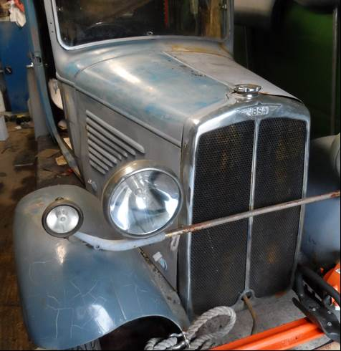

07801525879

